  PYTHON CODE RUNNING | PRACTICE CODES  Haleema Sajid

Task 1:
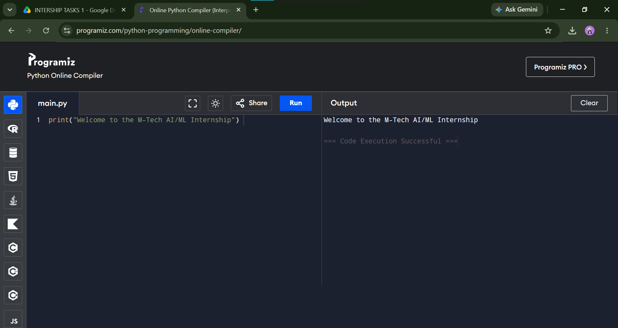
Task 2:
Variables and arithmetic:
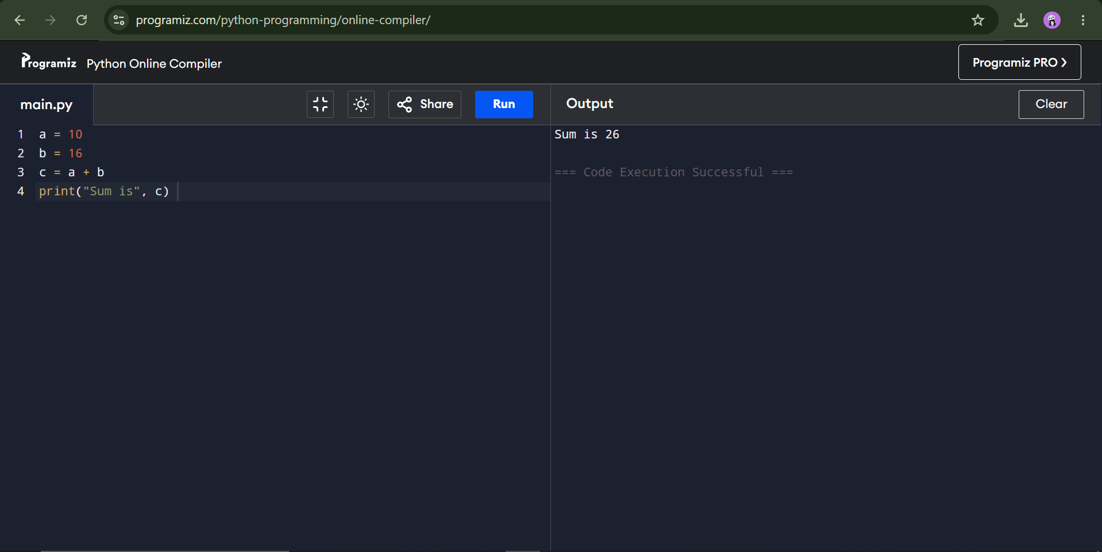
Task 3:
Taking input from the user:
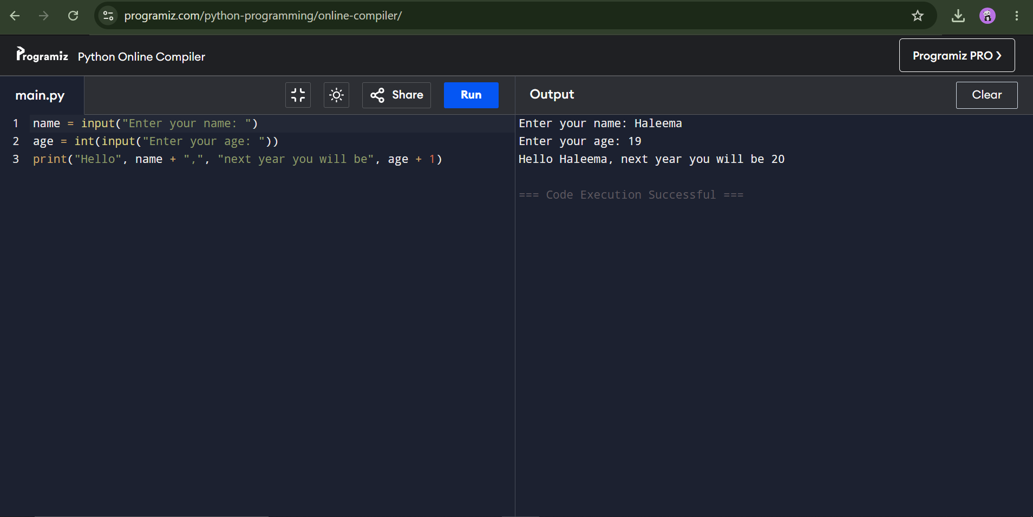
Lab tasks:
Task 1:
Write a program that asks the user for two numbers and prints their sum, difference, product and quotient.
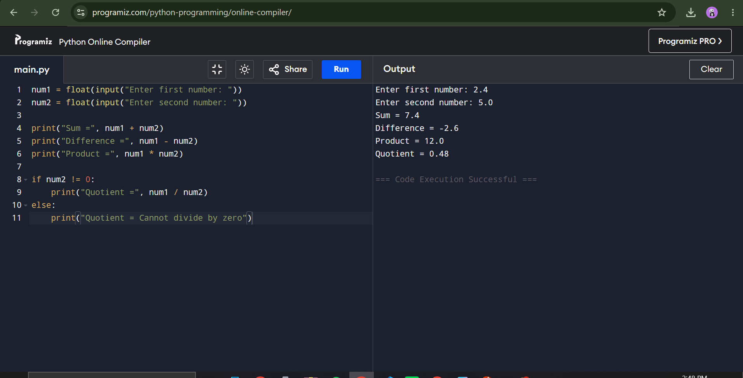
Task 2: Write a program that asks for a temperature in Celsius and prints it in Fahrenheit (F = C*9/5 + 32).
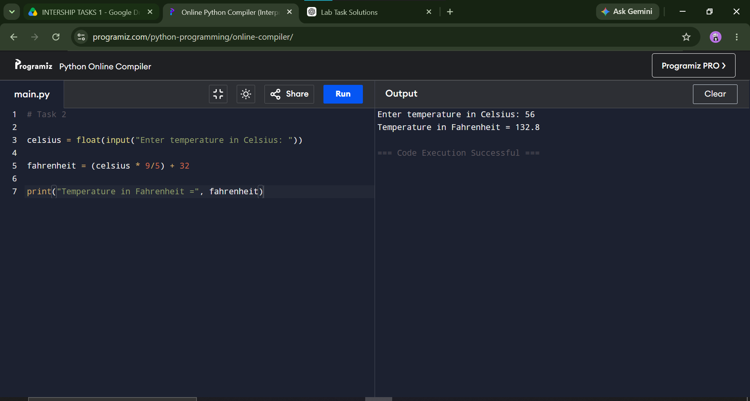
Task 3: Write a program that asks the user for their name and prints "Hello NAME" five times using a loop.
